**Requirements**

# Domain:

The application ‘EasyMath’ to be developed belongs to the entertainment domain. This is essentially a gaming application. EasyMath will be specifically designed for android mobile platform, thus targeted at a market of approximately 1.4 billion people.

# Problem:

Math is a skill that is useful in our day to day life. However, there are a lot of people who cannot do basic arithmetic calculations quickly. The biggest problem that we would face will be teaching the users basic mathematics incrementally. This would lead to multiple sub problems. The first one would be to determine the difficulty levels and determining the factors involved in every difficulty. The interface needs to be simple so that even children can use it. Also, implementing a way to track the progress of the user will be a challenge.

# Purpose and Audience:

Mathematics today, has more use than ever. Every aspect of computer science requires basic mathematics. Using this application, the users can improve the speed with which they can do some basic arithmetic. This way, people can stop relying on calculators for common mathematics. As a result, it can have a significant impact on the computer science community. It can increase the productivity of the users. The target audience for this application would be the common public of all age groups who want to learn/improve their math.

# Story Line:

## Registration and login:

In order the register, the user clicks on the register button. This will open up a sign up page. The user will be required to fill in the necessary details such as an email address, username, password and date of birth. The user clicks on the submit button to register with the application.

After registration, the user clicks on the login button to login. The user then inputs the username and password given during the registration. The user clicks on the login button to log in to the application.

## Gameplay:

When the user is logged in. The user will click on the new game button in the main menu to start a gameplay. This will open up a window containing 3 choices namely ‘*Easy*’, ‘*Medium*’, ‘*Hard*’. A recommended option will be already chosen according to the age of the user. However, the user can select appropriate difficulty level and click ok. This will start the gameplay.

Some arithmetic questions will pop up on the screen. The user has to input the answer using the keypad and click ok. The application responds to the user’s input, by giving a message indicating if the answer was right or wrong. If the provided answer is wrong, it will show the correct answer. The progress can be tracked by the user in the progress report.

## Progress Report:

The user clicks on the progress button in the main menu. This will open up a window where user can view the total score till date. The user will gain points according to the scoring system. Greater difficulty will reward higher points.

# UML diagrams:

Figure 1

Use case diagram for Easy Math

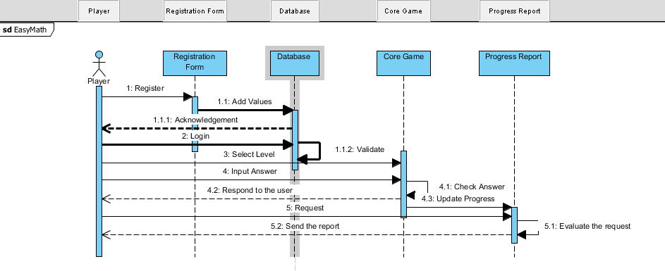

Figure 2

Sequence Diagram for Easy Math

# Required Functionality: